Project Design Phase-II
Technology Stack (Architecture & Stack)

Date | 26 June 2026
Team ID
Project Name | Metro Ticket Generating System
Maximum Marks | 4 Marks

Technical Architecture:
The Deliverable shall include the architectural diagram as below and the information as per the table1 & table 2

Table 1: Components & Technologies
Metro Ticket Generating System – Architecture Components
S.No | Component | Description | Technology
1 | User Interface | Passenger Portal and Administrator Portal for ticket booking, station management, and booking history. | ServiceNow Service Portal / Workspace / Forms / Lists
2 | Application Logic | Handles user authentication, ticket booking, fare calculation, payment validation, QR ticket generation, and booking status updates. | Business Rules, Client Scripts, Script Includes, UI Policies
3 | Workflow Automation | Automates ticket booking workflow, payment confirmation, QR ticket generation, and notification process. | Flow Designer
4 | Database | Stores passenger information, station details, metro routes, fare rules, ticket bookings, payment records, and QR ticket data. | sys_user, Metro Ticket Table, Station Table, Route Table, Fare Table (Custom Tables)
5 | Email & Notification Service | Sends booking confirmation, payment confirmation, QR ticket, cancellation, and reminder notifications to passengers. | ServiceNow Notifications, Email Service
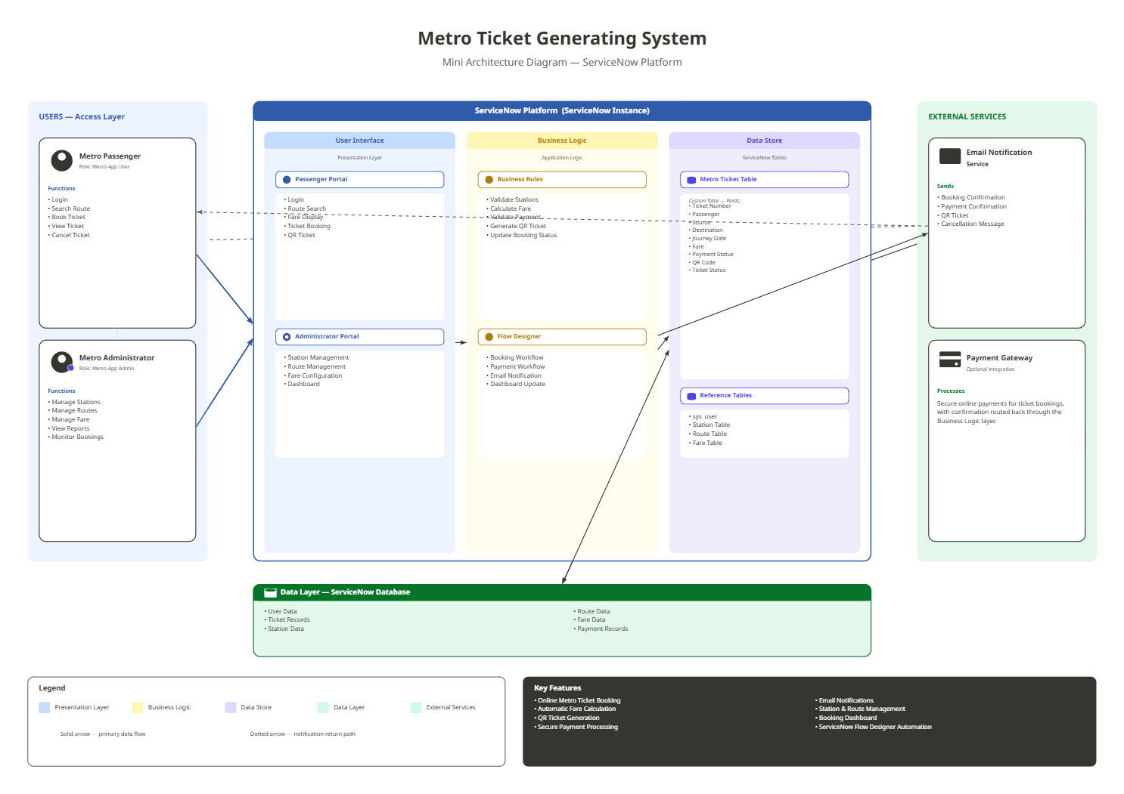

Table 2: Application Characteristics
System Characteristics – Metro Ticket Generating System
Characteristic | Description | Technology
Security | Role-based access ensures that passengers can access only their own ticket bookings, while administrators can manage stations, routes, fares, and bookings. | ACLs, Roles (x_metro_app.user, x_metro_app.admin)
Scalability | Supports increasing numbers of passengers, metro stations, routes, and ticket bookings without major architectural changes. | ServiceNow Platform
Availability | The application is available whenever the ServiceNow instance is operational, enabling passengers to book tickets anytime. | ServiceNow Cloud
Performance | Provides fast ticket booking, fare calculation, QR ticket generation, and workflow execution with minimal response time. | Flow Designer, Business Rules
Reliability | Maintains accurate ticket booking records, payment status, QR ticket data, and notifications without data loss. | ServiceNow Database
Usability | Offers a simple, intuitive interface for passengers and administrators to perform booking and management tasks efficiently. | Service Portal, Workspace, Forms & Lists
Maintainability | Allows easy updates to stations, routes, fare rules, and workflows through configurable ServiceNow components. | Flow Designer, Script Includes, Business Rules
Interoperability | Supports integration with external payment gateways and notification services for seamless ticket booking. | REST APIs, IntegrationHub

